Setting up Python Web Development on Windows

Last Updated: 6.6.2016

1. Download Git-Bash via the download from <https://git-scm.com/download/win>. Proceeding with the default installation settings should be fine.
2. Install python by going to <https://www.python.org/downloads/release/python-2711/>. Select the [Windows x86 MSI installer](https://www.python.org/ftp/python/2.7.11/python-2.7.11.msi) link to download and install python for Windows. The default installation options should be fine, but be sure to select the option to install “pip” when you reach the following screen:

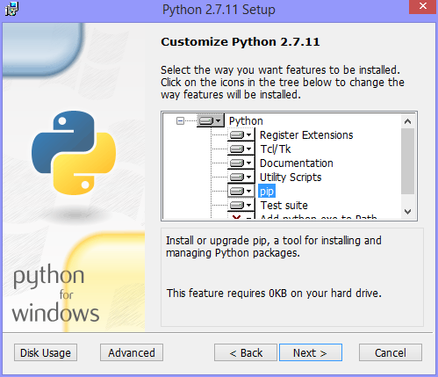

1. Add pip to the Windows path by following these instructions (Adapted from https://www.java.com/en/download/help/path.xml)
2. In Search, search for and then select: Advanced System Settings
3. Click the **Advanced system settings** link.
4. Click **Environment Variables**.

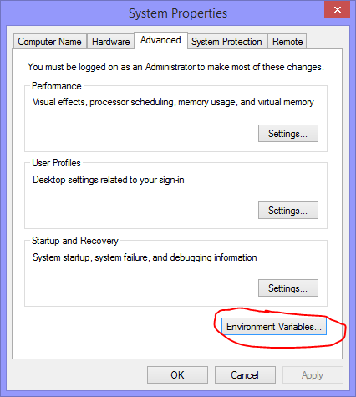

1. In the section **System Variables**, find the PATH environment variable and select it. Click **Edit**. If the PATH environment variable does not exist, click New.
2. In the **Edit System Variable** (or **New System Variable**) window, edit the “value” of the PATH environment variable. Add the text C:\Python27\Scripts, preceded by a comma, to the end of the existing PATH

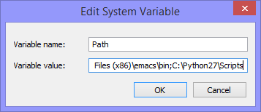

1. Go to your Desktop or other preferred file location to run the application via Windows Explorer. Right click within the window and select “Git Bash Here.” A window similar to the follow should show up:

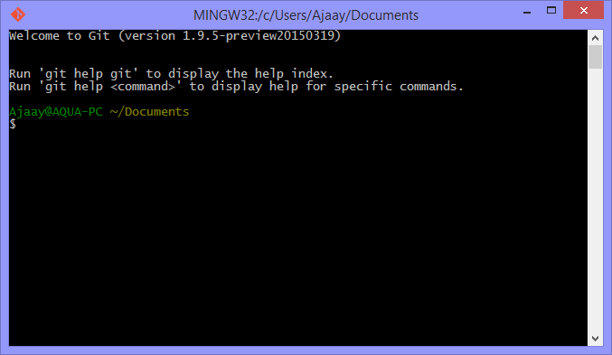

1. In the window, enter the following text and press enter afterwards:

*git clone https://github.com/ajaayc/ArrivalTimeStamp.git*

1. Type the following text into the window and press enter after every line:

*pip install --upgrade pip*

*pip install virtualenv*

*virtualenv venv*

*. venv/Scripts/activate (. venv/bin/activate if on Mac or Linux)*

*pip install -r requirements.txt*

*python app.py*

1. Go to your preferred web browser (e.g. Google Chrome, Internet Explorer, Firefox), and visit the following URL: localhost:5000.